**Chapter 1. Introduction**

**1.1. Relevance/Significance:**

The importance of proposed automated braking system is to detect the obstacle (i.e. vehicles) ahead and apply the corresponding braking pressure.

**1.2. Problem Statement:**

To design an automated system that constantly checks the distance between two approaching vehicles and to take respective actions to try and prevent accidental situations.

**1.3. Specifications:**

1. Distance Sensor (Range: 4cm to 10m)

2. AVR Microcontroller (AT Mega 16)

3. LCD Display (16x2)

**1.4. Platform used:**

Hardware:

1. Microcontroller: AT MEGA 16A with 8MHz Internal clock

2. 16x2 LCD screen: 16x2 LCD screen with 5x7 dot matrix display and backlight as well as contrast control pin.

3. Distance Sensor: 2cm to 4m ultrasonic distance sensor with internal 40 KHz oscillator.

4. Power Supply (Battery): 12V, 7A Lithium Battery for power supply.

5. USB ASP Programmer: 10 Pin ISP Programmer for boot loading purpose

Software:

1. Atmel Studio (7.0): Atmel Studio (7.0) is used for the purpose of writing and compiling program. This is a cross c compiler that uses

AVR architectures for embedded c programming support.

2. Proteus (7.0): Proteus Professional 7.0 is used to simulate the desired hardware’s in virtual screen to see if we can get the desired output.

3. Eagle: Eagle Professional 7.2.0 is used to design and generate PCB layout for etching purpose and PCB design

**1.5. Advantages:**

Compared to normal human operated braking the automated braking system is preferable because it eliminates the human errors, negligent driving.

**1.6. Applications:**

* In family cars.
* In vehicles of partially handicapped persons, pregnant women and senior citizens.
* Amateur drivers.
* Public transport vehicles.

**1.7. Organization of report:**

Chapter 1: The overall basic topics are covered in this chapter. Like problem statement, specifications, Platforms used, applications.

Chapter 2: The survey of this topic, recent usage of this project and study of each components.

Chapter 3: Calculations, Design and implementation of components and selection criteria.

Chapter 4: Simulation results, PCB testing, H/W results and description, Reviews and Enclosure design.

Chapter 5: Conclusion and Future Scope.

**Chapter 2. Literature Review**

**2.1. Recent Trends/State of Art:**

Ready or not, automatic braking is coming to a car near you, and probably sooner than you expect it. Fully autonomous vehicles that drive themselves from point A to B are still in the future, but braking systems that step in to slow or stop a vehicle without the driver’s intervention are here today, and about to become more common. Automatic braking will eventually make cars safer, reduce injuries and the cost of accidents, but there will be hiccups along the way. They will not prevent all collisions, and they will generate a new category of quality complaints for automakers and vehicle owners. That’s because not all automatic braking systems are created equal. If you think drivers get annoyed by bad voice recognition or finicky audio and climate controls, just wait ‘til they start reacting to phantom braking, false-positive collision alarms and collisions that happen despite the fact that their car has automatic braking. Tuning the systems correctly will be vital not just for safety, but for customer satisfaction.

The technology for automatic braking is still in its early days, but regulation and consumer demand is rapidly pushing it into more vehicles around the world. **New study has found 70% of consumers want automatic braking, self-parking and other driver aids.The U.S. government was considering making automatic braking mandatory, but BMW, Ford, General Motors, Toyota, Volkswagen and Volvo agreed earlier this year to work with regulators and the insurance industry on a voluntary plan to put them in all vehicles.** The history of the last two decades shows that customers vote for safer vehicles with their pocketbooks. For instance, curtain air bags are not mandatory, but try to find a new vehicle without them. **The Insurance Institute for Highway Safety says 1% of 2015 vehicles had standard automatic braking.**

We have seen acute revolution in implying artificial intelligence in cars, i.e. making it smart in every way. The fields in which there have been development are ABS, smart suspensions, crash prone chassis, automatic parking, weather sensor, day/night headlamps etc. one of them being the automated braking system. For safety purpose numerous companies have developed the automatic braking system using their own methodology. Volvo is one such company which has implemented automatic braking system in their vehicles. Mounting sensors besides the headlamps and sending the signals to the dashboard is the basic working principle of most of the vehicles. But there has been a problem in calibrating the object which comes in its path. Even for small objects like coke cans this vehicle stops. Thus the problem arises of vehicle braking automatically for the objects upon which it can pass easily. This has been overcome by Nissan. It has developed the object height sensors which can detect the size of the object and easily pass upon it.

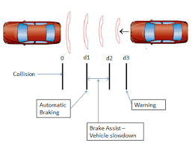

Fig. 2.1: Working of sensors of automatic braking system [11]

The Mercedes S-class is step ahead. Nor does it only applies break but also turns the vehicle if possible.

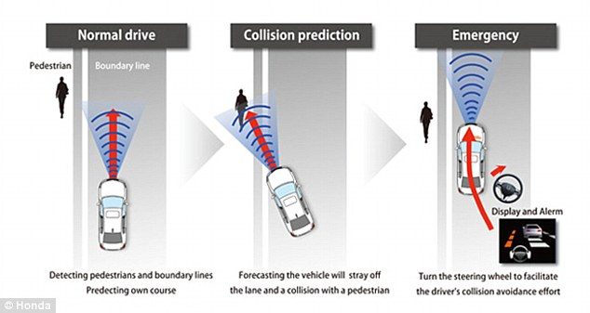 Fig.2.2. Sensors of Honda [12]

The same can be applied in any type of vehicles where safety is prime concern such as School bus, Public transportation, amateur drivers etc.

A plan has been proposed that in near future all vehicles will have automated breaking system and also their own intelligence to sense approaching every obstacle and act accordingly.

**2.2. Literature Survey:**

1) Fuzzy automated control system by Piero P. Bonissone and Kareem *S.* Aggour.

In this paper it is proposed to use a system with two fuzzy controller for automation of braking system. Here they determined static coefficient between tire and road, distance between two vehicles, relative velocity of the vehicles and determines the amount of brake pressure that must be applied in order to prevent accident.

2) Observer based emergency braking control in automated highway systems by Luis Alvarezt, Jingang Yit, Roberto Horowitzs and Luis Olmos

In this paper we determine the distance between two vehicles, longitudinal velocity of vehicles and static friction between two vehicles. It determines whether the environmental conditons are okay to drive at particular speed and accordingly it displays on the roadside for other vehicles to follow as well.

3) Fundamentals of Vehicle Dynamics by Gillespie.

In this book fundamentals of brake working and all the other formulas regarding vehicle dynamics are referred.

**2.3. Study of system components:**

1. Microcontroller: Atmega16A

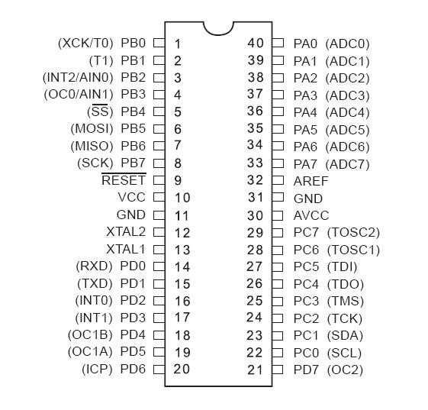

Fig.2.3 Pin diagram of Atmega16A [16]

􀁺 High-performance, Low-power Atmel AVR 8-bit Microcontroller

􀁺 Advanced RISC Architecture

̶ 131 Powerful Instructions – Most Single-clock Cycle Execution

̶ 32 x 8 General Purpose Working Registers

̶ Fully Static Operation

̶ Up to 16MIPS Throughput at 16MHz

̶ On-chip 2-cycle Multiplier

􀁺 High Endurance Non-volatile Memory segments

̶ 16KBytes of In-System Self-programmable Flash program memory

̶ 512Bytes EEPROM

̶ 1KByte Internal SRAM

̶ Write/Erase Cycles: 10,000 Flash/100,000 EEPROM

̶ Data retention: 20 years at 85°C/100 years at 25°C(1)

̶ Optional Boot Code Section with Independent Lock Bits

􀁺 In-System Programming by On-chip Boot Program

􀁺 True Read-While-Write Operation

̶ Programming Lock for Software Security

2.16x2 LCD:

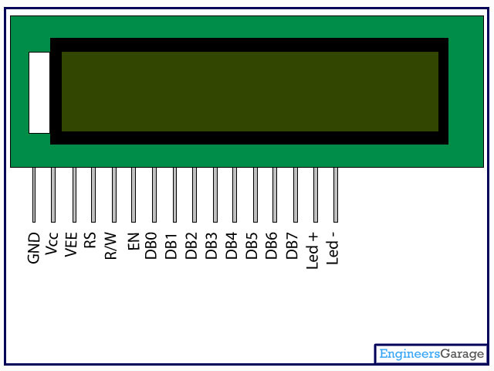

Fig.2.4 LCD [15]

LCD (Liquid Crystal Display) screen is an electronic display module and find a wide range of applications. A 16x2 LCD display is very basic module and is very commonly used in various devices and circuits. These modules are preferred over seven segments and other multi segment [LED](http://www.engineersgarage.com/content/led)s. The reasons being: LCDs are economical; easily programmable; have no limitation of displaying special & even [custom characters](http://www.engineersgarage.com/microcontroller/8051projects/create-custom-characters-LCD-AT89C51) (unlike in seven segments), [animations](http://www.engineersgarage.com/microcontroller/8051projects/display-custom-animations-LCD-AT89C51) and so on.

A **16x2 LCD** means it can display 16 characters per line and there are 2 such lines. In this LCD each character is displayed in 5x7 pixel matrix. This LCD has two registers, namely, Command and Data.

The command register stores the command instructions given to the LCD. A command is an instruction given to LCD to do a predefined task like initializing it, clearing its screen, setting the cursor position, controlling display etc. The data register stores the data to be displayed on the LCD. The data is the ASCII value of the character to be displayed on the LCD.

Pin Description:

**Table 1**

|  |  |  |
| --- | --- | --- |
| **Pin No** | **Function** | **Name** |
| 1 | Ground (0V) | Ground |
| 2 | Supply voltage; 5V (4.7V – 5.3V) | Vcc |
| 3 | Contrast adjustment; through a variable resistor | VEE |
| 4 | Selects command register when low; and data register when high | Register Select |
| 5 | Low to write to the register; High to read from the register | Read/write |
| 6 | Sends data to data pins when a high to low pulse is given | Enable |
| 7 | 8-bit data pins | DB0 |
| 8 | DB1 |
| 9 | DB2 |
| 10 | DB3 |
| 11 | DB4 |
| 12 | DB5 |
| 13 | DB6 |
| 14 | DB7 |
| 15 | Backlight VCC (5V) | Led+ |
| 16 | Backlight Ground (0V) | Led- |

3. Distance sensor: HC-SR04

HC-SR04 is an ultrasonic ranging module that provides 2 cm to 400 cm non-contact measurement function. The ranging accuracy can reach to 3mm and effectual angle is < 15°. It can be powered from a 5V power supply.

[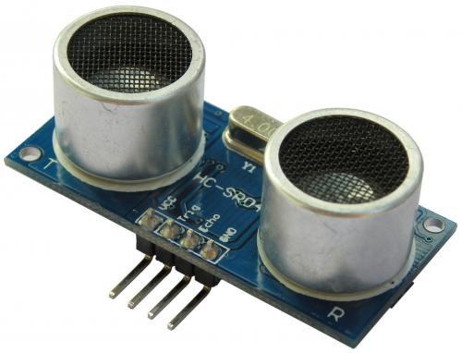](http://www.electroschematics.com/wp-content/uploads/2013/07/HC-SR04.jpg)

Fig.2.5 HC-SR 04 [13]

HC-SR04 Specifications:

* Working Voltage: DC 5V
* Working Current: 15mA
* Working Frequency: 40Hz
* Max Range: 4m
* Min Range: 2cm
* Measuring Angle: 15 degree
* Trigger Input Signal: 10µS TTL pulse
* Echo Output Signal Input TTL lever signal and the range in proportion
* Dimension 45 * 20 * 15mm

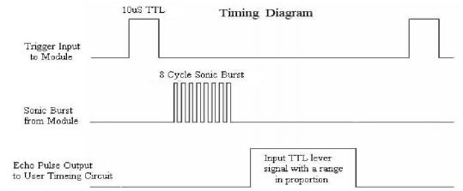

Fig.2.6. HC SR04 Timing diagram [14]

Timing diagram of HC SR-04 is as shown above. First waveform indicates the 10 µS TTL high pulse that is given to the trigger pin of HC SR-04 to initialise the sensor. This ultrasonic sensor then generates 8 cycle bursts of 40 KHz ultrasonic sound waves which are transmitted and echo pin is raised. This Echo pin here is proportional to the distance of object from the distance sensor. There is direct proportionality between distance and echo pulse high width.

**Chapter 3. Design and Development**

**3.1. Block Diagram and Description**

This is the basic Block Diagram for the proposed project as shown in Fig 3.1 consists of following components, Ultrasonic Distance Sensor which can sense the appropriate distance between the obstacle and tracked (ours) vehicle or between Tracking vehicle, Microcontroller i.e. AT Mega 16A, 16x2 LCD Display to display Distance and Velocity & an external Power Supply.

Distance

Sensor

Power Supply

Microcontroller

16 X 2

LCD

Fig 3.1 Block Diagram of Automated Braking System

**Description**

In the proposed system distance between tracking vehicle and the tracked vehicle is observed with the help of a Distance Measurement sensor, this sensor will calculate the distance between two vehicles and then will provide us with the result (i.e. Distance). Observing consecutive outputs of the sensor we calculate the relative velocity of two vehicles. Obtained distance and calculated relative velocity will then be converted in appropriate form (ASCII) so that it can be displayed on the 16x2 LCD that we are interfacing with the given system. Now when any of these parameters (i.e. Distance or Relative Velocity) goes beyond the limit (i.e. Relative velocity beyond +5 Km/Hr when distance is more than 1 meter) appropriate actions shall be taken to prevent the accidental situation. These actions involve applying of appropriate amount of brake pressure proportional to the value of distance measured and the value of relative velocity calculated.

**3.2. Selection of Components Criteria:**

**Hardware’s required:**

1. Microcontroller:

Even though PIC microcontroller was conducted in regular university curriculum and it is advised ideally to use PIC controller here we are opting against it. Reasons behind that are:

* AVR controller are cheaper than that of the PIC controller whereas providing almost similar performance criteria or even better at times. Being cheap or affordable and small in size are first main objectives of going for design of embedded system.
* With the help of At Mega 16 all the functionality that we desire to obtain in the given system can be obtained efficiently utilising almost all of the port pins.
* At Mega provide high frequency in built clock and hence it reduces our expensed in terms of money as well as in terms of space that oscillator circuit occupies on the PCB.
* Even though few of the pins of given controller are left floating here, these pins can be used in further development of the system and hence reducing the investment required later on for the improvement in the system.

1. 16X2 LCD screen:

* It is fairly easy task to decide which LCD display to pick, with 16x2 display satisfying all of our needs of parameters that are to be displayed and also its relatively small size occupying lesser space on designed PCB.

1. Distance Sensor:

* There are plenty of distance sensor available that give high precision and fast output but HC SR-04 is not only less expensive but also gives the distance to a very high precision value.

1. Power Supply:

* For Power 12 Volt 7A battery is used and reason behind selecting battery with such a high current rating is that we are supposed to run a 4 motors of 500 RPM on this battery as well as we need to supply the voltage to the controller.

**Software’s used:**

1. Atmel studio 6.0 - Atmel Studio 6 is the integrated development platform (IDP) for developing and debugging Atmel® SMART ARM®-based and Atmel AVR® microcontroller (MCU) applications. Studio 6 supports all AVR and Atmel SMART MCUs. The Atmel Studio 6 IDP gives you a seamless and easy-to-use environment to write, build and debug your applications written in C/C++ or assembly code. It also connects seamlessly to Atmel debuggers and development kits.

2. Proteus 8.0 - Proteus 8 is a best simulation software for various designs with microcontroller. It is mainly popular because of availability of almost all microcontrollers in it. So it is a handy tool to test programs and embedded designs for electronics hobbyist. You can simulate your programming of microcontroller in Proteus 8 Simulation Software. After Simulating the circuit in Proteus 8 Software we can directly make PCB design with it so it could be all in one package for students and hobbyists.

3. Eagle 6.6 - EAGLE is a program for designing PCBs. The program comes with a schematic editor for drawing circuits and a layout editor for drawing PCBs. You can export the layout as Gerber files, which can be used at most of the board houses. Flexible User Language Programs (ULPs) enable custom features, such as individual instruction sequences, simulation, and data export/import.

**Technical Specifications:**

1. Distance Sensor with Range between 2cm to 4 m
2. AVR Microcontroller with high speed operation
3. 16x2 LCD display

**3.3. Design Calculations: (Formulae)**

For the vehicle,

1. Stopping Distance = [V02/ (2 * Fxt)]/M ……(I)

**=** V02 /2 * Dx ……(II)

Where ,

V0= Initial Velocity

Fxt= Total longitudinal forces on the vehicle(Brake)

` M= Mass

Dx= Linear Deceleration.

2. Time to stop = [(V0/Fxt)/M] ……..(III)

= V0/Dx ….......(IV)

where,

V0= Initial Velocity

Dx = Linear Deceleration

**3.4. Circuit Design: (Circuit Schematic)**

Vf = Vin +at ……… (V)

Where,

a = deceleration

a = -Vo^2/2d ……… (VI)

* General Equation For Braking Performance:-

Max = -w/g * Dx = -Fxf-Fxz-Da-wsin (Ø) ……... (VII)

Where,

w = Vehicle’s weight

g = gravitational acceleration

Dx = -ax = Linear deceleration

Fxf = Front axle braking source

Fxz = Rear Axle Braking Source

Da = Aerodynamic drag

Ø = Uphill Grade

* Minimum Pulse Width for reset pin = 2.5µs

Reset Pin Threshold Voltage = 0.1 Vcc to 0.9Vcc

* Reset Circuit =

Z = RC

Z= 10^-7

RC = 10^-7

Let R = 40K

C = (10 X 10^-6)/40 X 10^3

= 0.25nF

Tc = RXC

R = 5 X 10^3

R = 5K

* Maximum DC current per i/o pin = 40mV
* Maximum DC current on Vcc& GND pins = 200mA
* Output High Voltage : -

4.1 V Ioh = -20mA Vcc = 5V

2.3 V Ioh = -10mA Vcc = 3V

* Output Low Voltage : -

0.8V Iol = 20mA Vcc = 5V

0.5V Iol = 5mA Vcc = 3V

* Ultrasonic Ranging Module:-

Working Voltage = 5 V

Current = 15mA

* Trigger Input Signal = 10 µs TTL Pulse
* Distance Sensor – HC – SR04 :-

Distance = (High level time X 340)/2

For 2 cm (Minimum Distance)

0.02 = (x * 340)/2

x = 0.04/340

x = 1.1764 X 10^-4 s

For 4m (Maximum Distance)

4 = (x * 340)/2

x = 8/340

x = 0.0235294 s

**3.5. S/W Design Steps (Algorithm/Flowcharts Explanations)**

* Algorithm:

1) Start.

2) Initialise 16x2 LCD, Timer of the system.

3) Initialise Sensor by giving trigger pulse.

4) After Initialisation, Detect if there is any obstacle.

5) Depending upon obstacle detected, check if the reflected wave is received at echo terminal.

6) If the reflected wave is received, according to the distance measured apply appropriate brake pressure.

7) Display the all the required parameters on 16X2 LCD Display.

8) End.

**Flowchart:**

START

END

DISPLAYING THE APPLIED PRESSURE ON 16x2 LCD

BRAKING PRESSURE

ULTRASONIC RECEIVER

OBSTACLE DETECTED

SENSOR INITIALISATION

INITIALISE TIMER AND LCD

IF WAVE IS RECEIVED

NO

YES

**3.6. PCB Artwork Design:**

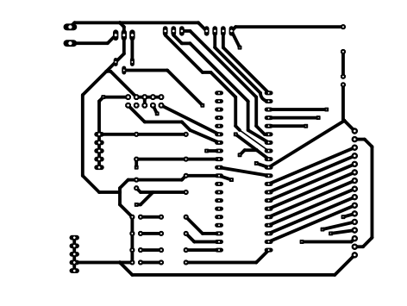

Fig.3.2 PCB Layout

**Steps** **for designing PCB Layout**

1. PLANNING: The planning stage is important in PCB designing. The components which are heavy or lengthy should not be mounted on PCB. The proper heat sink should be given to the components which are giving heat .The spacing between conducting line should be planned. The lines carrying high current should be large in size. The ground line which provides earths for various components should be large in area.
2. TRANSLATION: The drawings of layout drown on the copper plate. The actual size of the circuit is checked carefully before operation starts. After layout is drawn, on paper the plan is transferred on PCB. This is done by neatly placing the carbon between the copper and planned circuit. The working plan is then traced carefully. If plan is simple then it can be drawn on copper paper it is better ideas.
3. CLEANING OF BOARD: When the board has been cut and smooth along its edge check it’s clean on the outside before the circuit plan is transferred. This is important because even the slightest grace will disturb the etching process if the circuit plan transferred on board neatly after the transferred of plan gives grace like sub trace on the copper structure it is very difficult to clean it. The PCB must be cleaned before the plan is transferred.
4. CORRECTING THE ERROR: When the resist is harder any error may be seen can be eliminated by scratching the resist using blade or knife. When the resist is harder a straight edge of blade can be employed to straighten the edges thus the problem of correcting the error does not arise.
5. ETCHING: After correcting the errors, etching is done to remove the unwanted copper on the board excluding tracks. The most frequently used etch is FeCL3 with a small quantity of HCL added to it. The copper board immersed into it. The depth of solution must be sufficient. The best etching temperature is between 37 to 42 degree centigrade. The warmer solution makes the etching process faster the time taken is 30-45 minutes.
6. FINISHING: When all the unwanted copper has been dissolved from the plane areas between conducting lines. The board is washed with running water. The resist then is removed by suitable solvent.
7. TESTING: After cleaning the PCB the continuity of the conducting lines is tested using multimeter. If any lines are shorted then using blade it can be removed.
8. DRILLING: After continuity tests the holes are drill in the PCB by drilling machine where they are necessary.
9. MOUNTING: After drilling the PCB the components are mounting where they are located with appropriate leads.
10. SOLDERING: Last step of complete the circuit board is soldering.

**Designing Steps:**

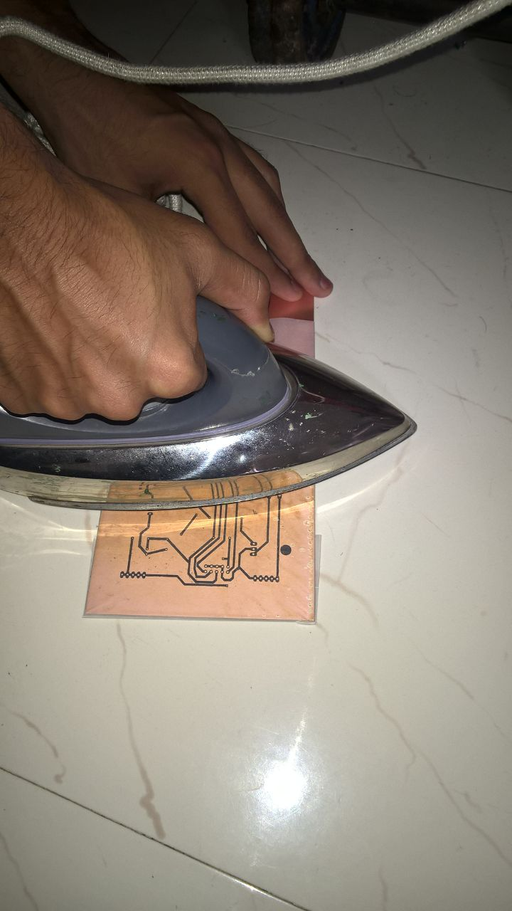

Fig.3.3 ironing the layout on PCB

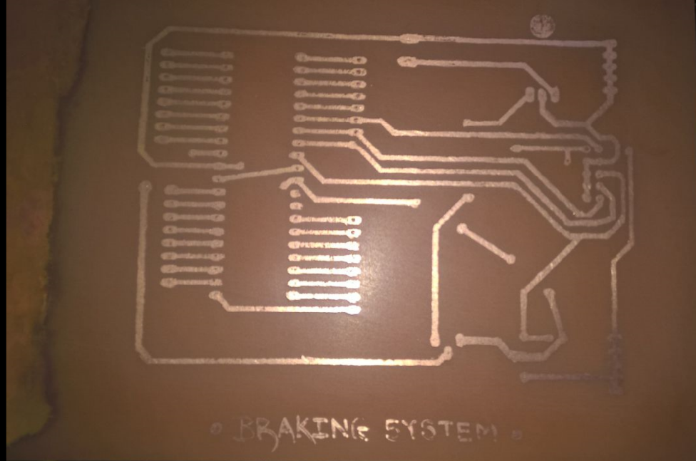

Fig.3.4 PCB Etching

**Chapter 4.** **Result and Discussions**

**4.1. Simulation, Results, Description:**

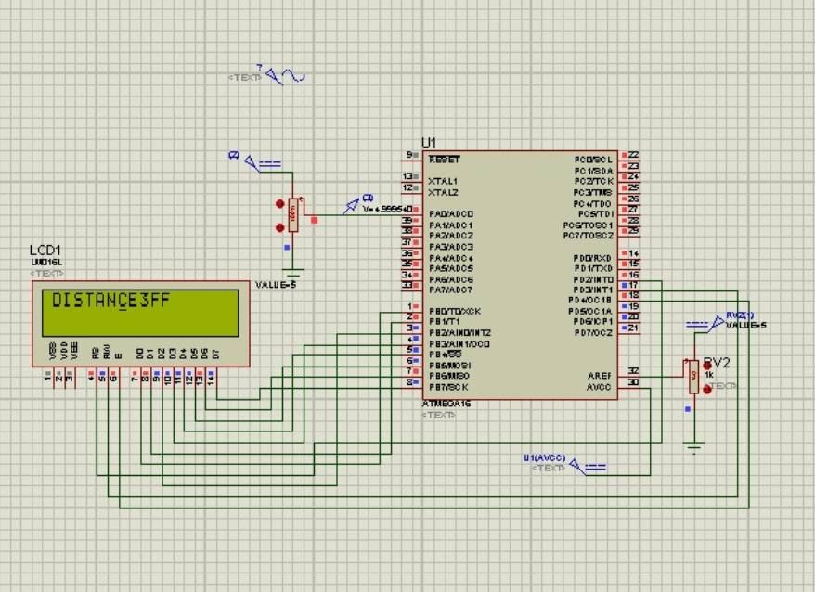

Fig.4.1 Simulation

Proteus professional software is used for this simulation. Because HC SR-04 is not present in proteus professional library here for simulation purpose we use a 5v supply which is connected to A-D converter and with respect to the voltage at the pin we display distance.

In simulation we need not connect the reset circuitry, oscillator circuit and vcc ground because all these are considered in simulation software internally. Here LCD data pins are connected to PORTB whereas volt input is taken at PORTA, PIN0. RS, RW, EN pins are connected to PORTD, PINS 2, 3, 4.

**4.2. Physical board testing, PCB testing:**

While testing of bread board all the reset circuitry, vcc and ground are to be connected in circuit as well as sensor is to be interfaced. While testing the circuit on breadboard number of wires connected are too high and hence it becomes complex to debug the problems in the circuit and hence here we have directly used development board for testing of program and other components.

We are using an external battery supply of 12V, 7A which is not directly compatible with the controller and hence we use IC 7805 to step down the voltage from 12V to 5V and to step down current from 7A to 1A. After physically connecting all the components we load program into controller with the help of USB ASP programmer. By applying the supply through battery here we observe the output.

**Problems Faced During Setup:**

* Not able to load the program HEX file in microcontroller via boot loader.
* There was unexpected overlapping of two copper lines while etching.
* Also, due to heavy voltage and heavy current supply, components were damaged while testing.
* Breakage of Microcontroller legs because of mishandling while removing and placing.

**4.3.** **Hardware results, Description:**

After loading program in microcontroller and resetting the circuit we get the desired output. As HC-SR04 sensor is moved towards or away from an object it displays approximate distance (with negligible error) between sensor and the object. If sensor and object both are stationary then as expected it gives zero relative velocity whereas if there is movement it gives relative velocity. Distance displayed is in centimeters and relati ve velocity in centimeter/microsecond as distance is measured over a microsecond cycle.

The relative velocity is measured in centimeter/microsecond so the output that we has high amplitude and hence we observe large amplitude even in change of small distance.

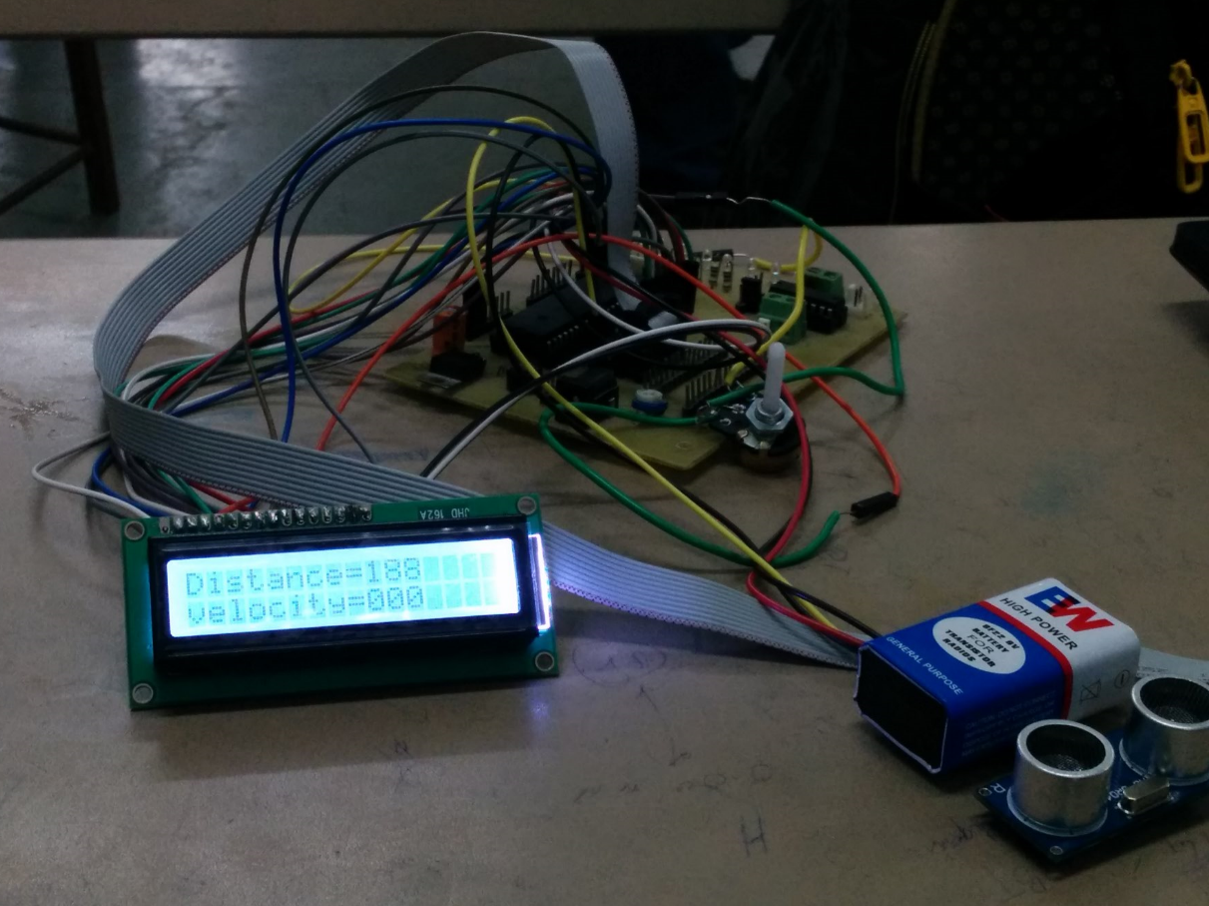

Fig.4.2. Actual implementation on PCB

**4.4. Difference between simulation and actual hardware:**

In simulation we need not connect the 5 pins of the LCD but in actual hardware implementation we need to connect these pins. Also the 3rd pin is for contrast control. The variable resistance is used here for contrast control at. Also there is problem in connecting pins and components like etching and soldering in actual hardware. But no such problem is faced in simulation. If some of the basic parameters such as clock input, input voltage are absent in simulation software those things are taken care of by simulator in order to make users life easy but same thing does not happen in hardware.

**4.5. Comments & Reasons:**

The proposed system thus shall work in terms of safety measures for automobile in order to try and prevent physical contact between two vehicles. It does the work of preventing collisions and also reduce neglected human errors to have minimum impact.

**4.6. Enclosure design:**

Enclosure design is a box of size 15x20 cm approximately which fits in all the components of the system and is mounted on the small remote operated bot.

**Chapter 5. CONCLUSIONS & FUTURE SCOPE**

**5.1. Conclusion:**

The discussed work here, assume that the subject vehicle was tracking another one on a flat, horizontal surface in a straight line. This analysis should be to the account for driving on a gradient. To simulate more realistic situations, we should also remove the assumption that the objects are moving in a straight line. A problem with this solution is that if the tracking vehicle were going around a curve, the sensors would read the velocity of the object directly in front of it, independent of the curvature. Thus, the system could be expanded to identify objects that are genuinely in the path of the subject vehicle and not objects on the side(s) of the road. In conclusion, the two-controller system accustomed to the algorithm worked very well for the problem stated. For the cases where stopping the vehicle without a collision was possible the system consistently applied sufficient and appropriate brake pressure to stop the vehicle in time with a final separation distance of approximately **1-3** meters. By having a computer react immediately to a potential collision situation, the controller still reacted immediately and applied a significant amount of brake pressure, minimizing the vehicle velocity at impact and thus reducing the significance of (damage due to) the collision.

**5.2. Future Scope:**

The total negligence during driving has led to mishaps on road. The human errors have to be reduced to avoid accidents. The cars have to be smart enough to brake themselves upon sensing danger. New study has revealed that every car manufactured in future are going to be connected to each other through smart GPS system. They will be able to communicate with each other. The person which is in hurry and needs to drive through quickly will be able to do so by other cars making way to the persons car. Automated driving will be possible. One of the features of this will be automated braking system. This is going to reduce deaths due to accidents on large scale. Physically disabled, senior citizens, children etc. are going to be benefited by this to a large extent.

**References:**

|  |  |
| --- | --- |
| [1] | **M.** Burckhardt, ***Fuhrwerktechnik: Radschlupfregelsysteme.*** Germany: Vogel-Verlag, **1993.** |
| [2] | U. Kiencke and A. **Daiss,** “Estimation of Tyre Friction for Enhaced ABS Systems,” in ***Proceedings*** ***of the AVEG’94,* 1994.** |
| [3] | J.K. **Hedrick, M. Tomizuka, and P. Varaiya**, “Control issues in Automated highway systems,” in ***the American Control Conference,*** (Seattle, Washington), pp. **165-169, 1995.** |
| [4] | L. Alvarez and R. Horowitz, “Safe platooning in AHS. Part I: safety regions design,” ***Journal of Vehicle Systems Dynamics,*** vol. **32,** no. **1,** pp. **23-56, 1999** |
| [5] | **L.** Alvarez and **J.** Yi, “Adaptive Emergency Braking Control in Automated Highway System,” in ***Proceedings of* 38th *IEEE Conference of Decision* And *Control,*** (Phoenix, **AZ), pp. 3740-3745,1999.** |
| [6] | E. Bakker, **L.** Nyborg, and H. Pacejka, “Tyre Modelling for Use in Vehicle Dynamic Studies.” Society of Automotive Engineers Paper # **870421,** |
| [7] | **J.** Lygeros, **D.** Godbole, and M. Broucke, “A Fault Tolerant Control Architecture for Automated Highway Systems,” ***IEEE Transactions on Control Systems Technology,*** vol. **8,** no. **2,** pp. **205-219, 2000.** |
| [8] | **L.** Alvarez, **J.** Yi, R. Horowitz, and L. 01- mos, “Adaptive Emergency Brake Control in AHS with Underestimation of Friction Coefficient,” in ***Proceedings of American Control Conference,*** (Chicago, IL), pp. **574-579, 2000.** |
| [9] | **L.** R. Ray, “Nonlinear Tire Force Estimation and Road Friction Identification: Simulation and Experiments,” ***Automatica,*** vol. **33,** no. 10. |
| [10] | Fundamentals of Vehicle Dynamics by Thomas D. Gillespie (Book) |
| [11] | <http://www.cvel.clemson.edu/auto/systems/auto-brake.html> |
| [12] | <http://www.slashgear.com/honda-sensing-advanced-driver-assistive-system-to-debut-on-honda-legend-in-japan-24352292/> |
| [13] | <http://www.instructables.com/id/Easy-ultrasonic-4-pin-sensor-monitoring-hc-sr04/> |
| [14] | <http://www.circuitdb.com/?p=1162> |
| [15] | <http://www.engineersgarage.com/electronic-components/16x2-lcd-module-datasheet> |
| [16] | <http://www.atmel.com/images/atmel-8154-8-bit-avr-atmega16a_datasheet.pdf> |